**Report Region Export**

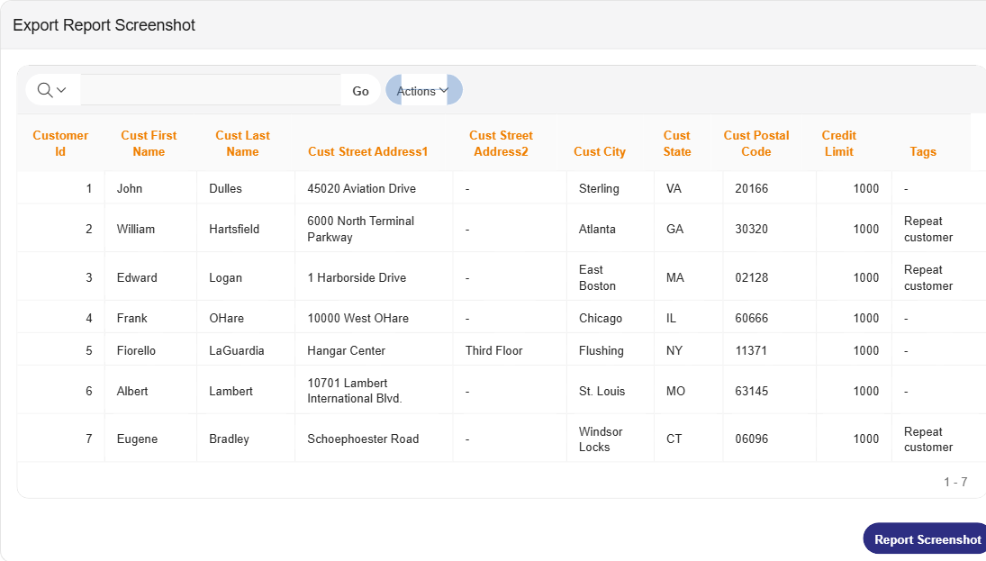

**Questions?**We are happy to help you!  
You can contact us by email on [support@apexofficeprint.com](mailto:support@apexofficeprint.com).  
Need help with converting your reports to AOP? [APEX R&D](https://www.apexrnd.com/) offers remote consulting and APEX services all over the world.  
If you want to speak to somebody local; [APEX R&D](https://www.apexrnd.com/) has offices in Europe and Australia (New-Zealand).