****Picture 0

Demo to show the usage of **HTML Tag** in DOCX.

This is text coming from the database / session in HTML format.  
It supports:

Lists with numbers:

1. **Bold**
2. *Italic*
3. Underline
4. ~~Strikethrough~~
5. Subscript
6. Superscript
7. Text Color
8. Background Text Color

Lists without numbers:

* item 1
* item 2

Heading 1

Heading 2

Heading 3

*Heading 4*

Normalt text with Font Change

Code font

| **THeader 1** | **THeader 2** |
| --- | --- |
| some text |  |
|  | some other text |

Other table with style:

| **THeader 1** | **THeader 2** |
| --- | --- |
| some text |  |
|  | some other text |

List of Customer Names from table:

**Albert**

**Edward**

**Eugene**

**Fiorello**

**Frank**

**John**

**William**

**HTML Tables**

**Default Table**

|  |  |  |
| --- | --- | --- |
| **Name** | **Age** | **Country** |
| Harry Depp | 28 | Britain |
| John Smith | 35 | USA |
| Ram Krishna | 19 | Nepal |

**Custom Table(named SampleTableAOP)**

| **Company** | **Contact** | **Country** |
| --- | --- | --- |
| Alfreds Futterkiste | Maria Anders | Germany |
| Centro comercial Moctezuma | Francisco Chang | Mexico |
| Ernst Handel | Roland Mendel | Austria |
| Island Trading | Helen Bennett | UK |
| Laughing Bacchus Winecellars | Yoshi Tannamuri | Canada |
| Magazzini Alimentari Riuniti | Giovanni Rovelli | Italy |
| Company 2 | Contact 2 | Country 2 |

**Image using HTML tag**

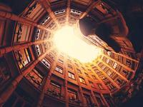

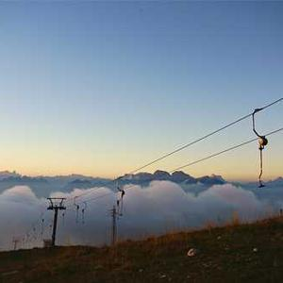

**Ordered and Unordered Lists**

**Nested ordered and unordered lists.**

1. Level 1.1
   * Level 2.1
   * Level 2.2
     1. Level 3.1
     2. Level 3.2
2. Level 1.2
3. Level 1.3

**List start at 10.**

1. Item 1
2. Item 2
3. Item 3

**List with type and style:**

1. Level 1.1
   1. Level 2.1
   2. Level 2.2
      1. Level 3.1
      2. Level 3.2
2. Level 1.2
3. Level 1.3

**List with custom ordered** **list style:**

1. Cat
2. Dog