Demo to show export of Multiple Interactive Reports
IR1
Customer Id | Cust First Name | Cust Last Name | Cust Street Address1 | Cust Street Address2 | Cust City | Cust State | Cust Postal Code | Phone Number1
1 | John | Dulles | 45020 Aviation Drive | - | Sterling | VA | 20166 | 703-555-2143
2 | William | Hartsfield | 6000 North Terminal Parkway | - | Atlanta | GA | 30320 | 404-555-3285
3 | Edward | Logan | 1 Harborside Drive | - | East Boston | MA | 02128 | 617-555-3295
4 | Frank | OHare | 10000 West OHare | - | Chicago | IL | 60666 | 773-555-7693
5 | Fiorello | LaGuardia | Hangar Center | Third Floor | Flushing | NY | 11371 | 212-555-3923
6 | Albert | Lambert | 10701 Lambert International Blvd. | - | St. Louis | MO | 63145 | 314-555-4022
7 | Eugene | Bradley | Schoephoester Road | - | Windsor Locks | CT | 06096 | 860-555-1835

IR2 (with control break)
Order name: Order 2, Order total: 2380
Product name | Quantity | Unit price | Image
Bag | 4 | 125 | 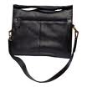
Belt | 2 | 30 | 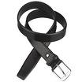
Blouse | 3 | 60 | 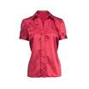
Business Shirt | 3 | 50
Jacket | 3 | 150 | 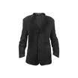
Ladies Shoes | 2 | 120 | 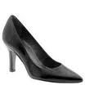
Mens Shoes | 2 | 110 | 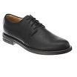
Skirt | 3 | 80 | 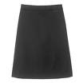
Trousers | 3 | 80 | 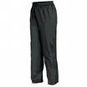
Wallet | 2 | 50 | 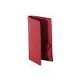

IR3 (IR exported as a chart)

