Interactive Report as shown on APEX application:
Product Name | Quantity | Unit Price | Image | Order Total | Order Name | Cust First Name | Cust Last Name | Cust City
Bag | 4 | 125 | 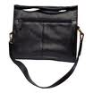 | 2380 | Order 2 | John | Dulles | Sterling
Belt | 2 | 30 | 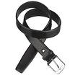 | 2380 | Order 2 | John | Dulles | Sterling
Blouse | 3 | 60 | 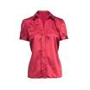 | 2380 | Order 2 | John | Dulles | Sterling
Business Shirt | 3 | 50 | 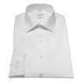 | 2380 | Order 2 | John | Dulles | Sterling
Jacket | 3 | 150 | 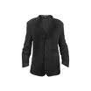 | 2380 | Order 2 | John | Dulles | Sterling
Ladies Shoes | 2 | 120 | 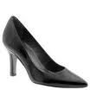 | 2380 | Order 2 | John | Dulles | Sterling
Mens Shoes | 2 | 110 | 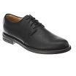 | 2380 | Order 2 | John | Dulles | Sterling
Skirt | 3 | 80 | 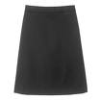 | 2380 | Order 2 | John | Dulles | Sterling
Trousers | 3 | 80 | 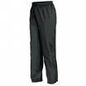 | 2380 | Order 2 | John | Dulles | Sterling
Wallet | 2 | 50 | 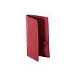 | 2380 | Order 2 | John | Dulles | Sterling

