Product | Wallet
EAN13
QR Code Link | 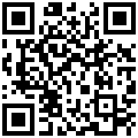

Questions?
We are happy to help you!
You can contact us by email on support@apexofficeprint.com.
Need help with converting your reports to AOP? United Codes offers remote consulting and APEX services all over the world.

