ABOUT APEX OFFICE PRINT (AOP)
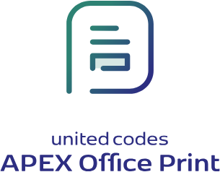
We care about printing and exporting your data.
APEX Office Print makes the printing and exporting of data in Oracle Application Express (APEX) easy. Design a template in Office, HTML, or text; choose your data from a database and merge them into one. You can easily export the result to Office or PDF and have your document in no time. AOP saves you time and effort by allowing you to define templates in which you can integrate your data.

Simple Templates
Create templates for your data in Word, Excel, PowerPoint, HTML, Markdown or Text.
Easy and Effortless
Define your data and integrate it into your template. Print out or export the data with great ease and little effort.
Facilitate, Accelerate, and Improve
Save time, effort, and most importantly: money. We make printing and exporting of data easy because we care about your business.

